**Audioscope**

Alba Zalli and Ameer Abd El-Fatah



**TABLE OF CONTENTS**

1. **Program Purpose**
2. **Installing and running the program**
3. **How to use**

**I. Start up**

**II. Start Screen**

1. Open Visualizer
2. Exit Program
3. Credits

**III. Visualizer**

1. Pausing and playing
2. Volume and viewport speed
3. Chords
4. Frequency and current speed
5. Chord and manual mode
6. Saving and Loading

**D. Key features**

1. **Program Purpose**

Audioscope provides both a visual and audio representation of inputted frequencies, allowing the user to toggle between manual and chord mode. This program provides an effective way for students to visualize the behaviour of soundwaves by exhibiting how waveforms interact visually and sonically. This is a tool that helps build understanding, and can be used to teach aspects of physics and sound by using a microtonal model.

Audioscope’s purpose is outlined in its name: audio references sound, while the -scope suffix means to see. Our goal is to create a tool that can help people visualize sound.

# Installing and Running the Program

To install the program, please click [**here**](https://drive.google.com/file/d/1qvTD4brMBSQXzjb9q-lITeMlMqQLHsA-/view?usp=sharing)and press the download button as shown below: 

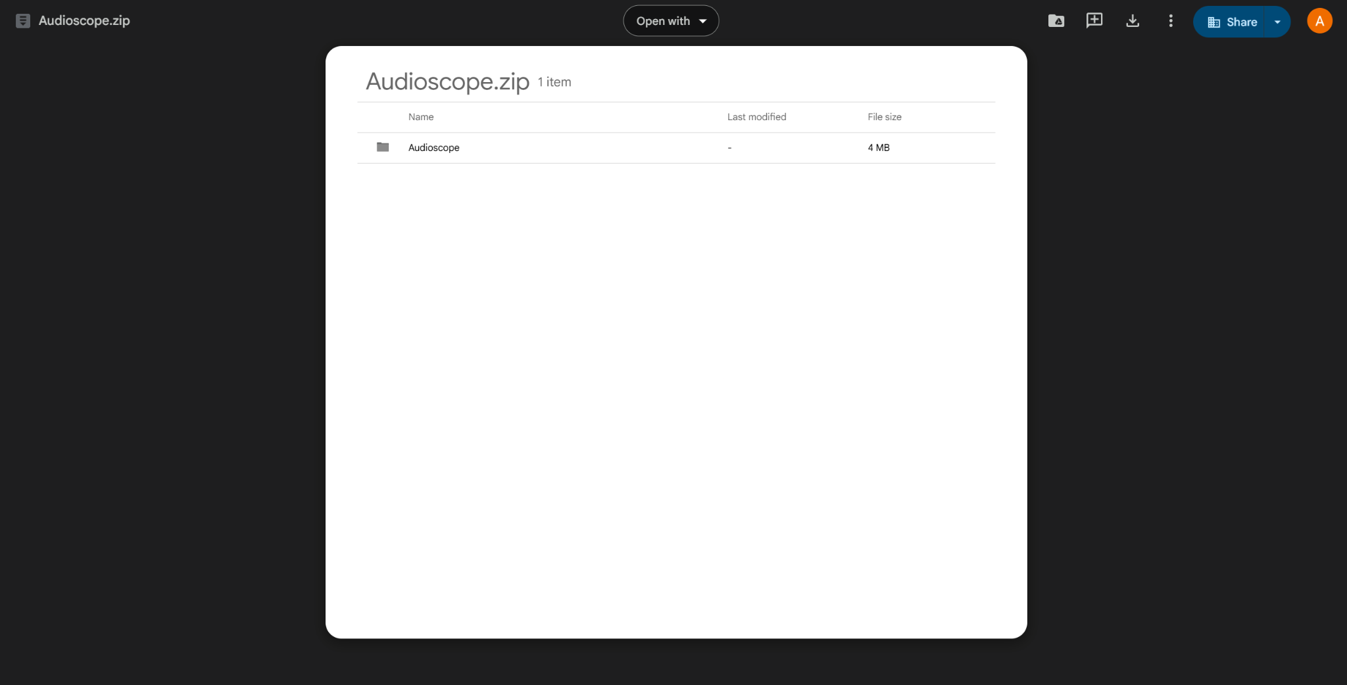

Once you click the download button, a new tab will appear, and a window will pop up to download the file. Feel free to save it to any location of your choice (or leave it as is) and press save!  
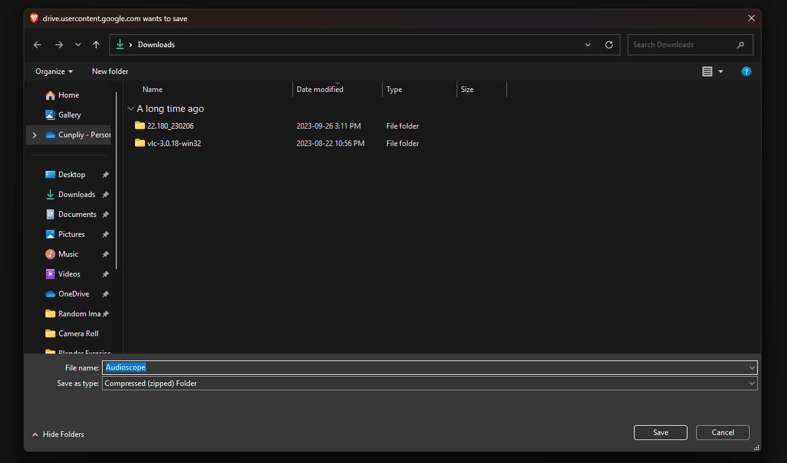

Once downloaded, open the file and press “Extract all”

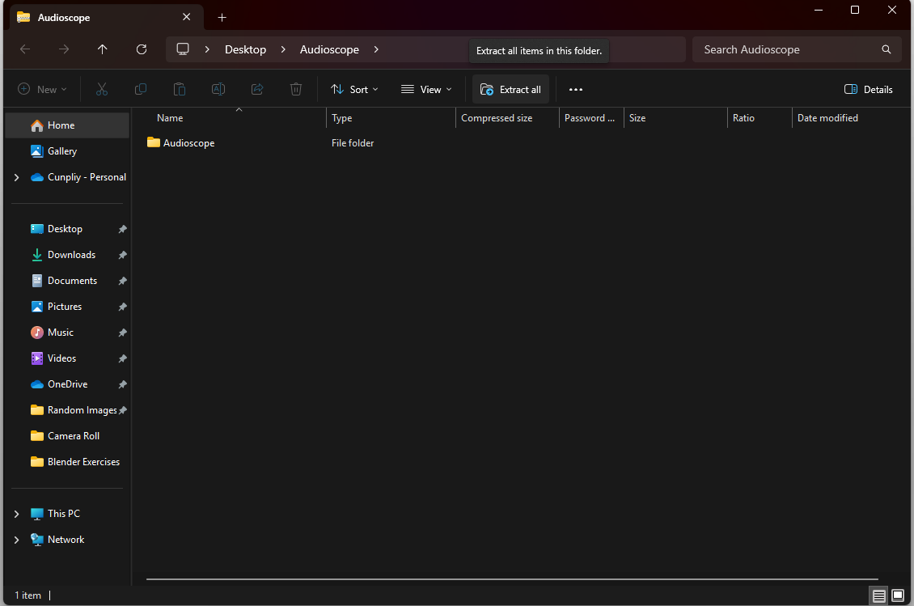

After pressing “Extract all,” this window will pop up; feel free to change where the extracted file is saved if you desire to. If you don’t want to just proceed with pressing “Extract”

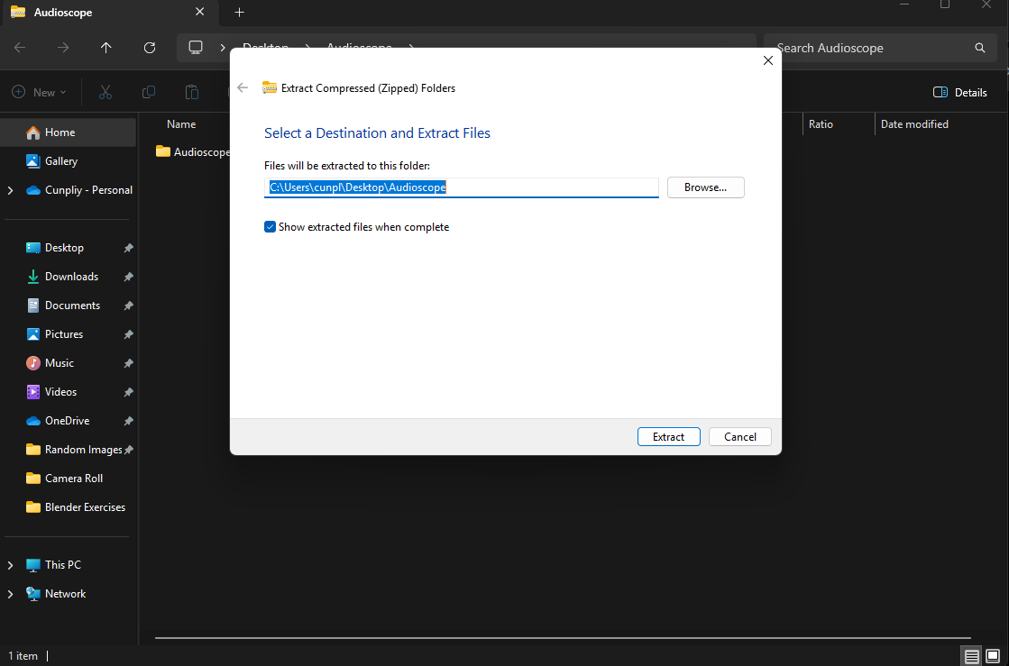

After pressing “Extract,” give it some time to extract the file; this normally takes a couple of seconds. Once it’s done, the new file will open. Double-click on the “Audioscope” folder to open it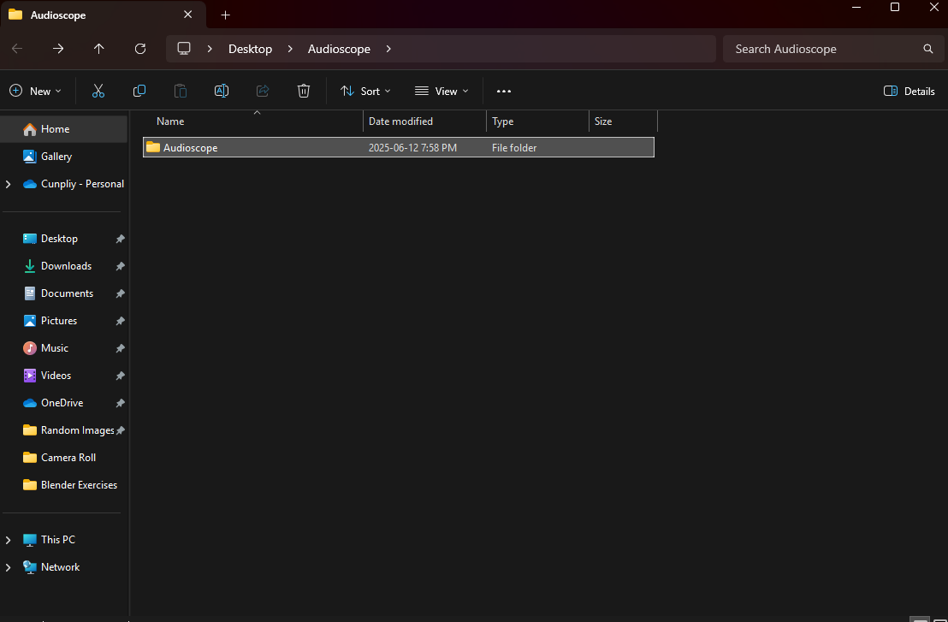

After opening the “Audioscope” folder, you will see an Executable Jar file called Audioscope; this is the program file. Double click to start running the program!

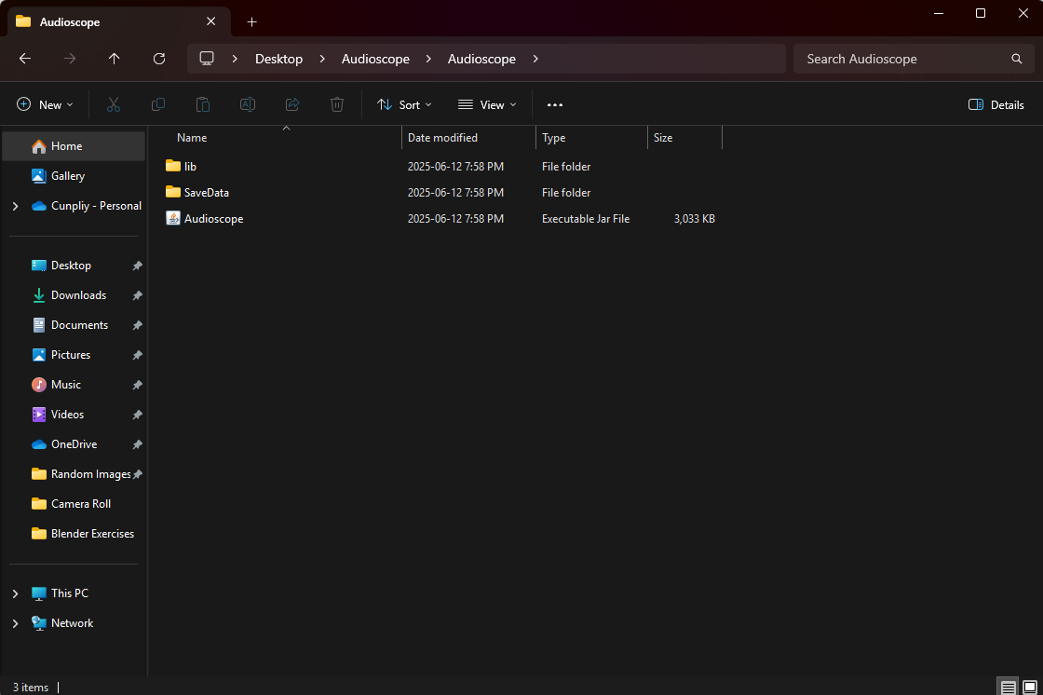

**Congratulations!** After running the program, you will see the start menu. You have successfully downloaded and opened the Audioscope program! Have fun messing around with it!

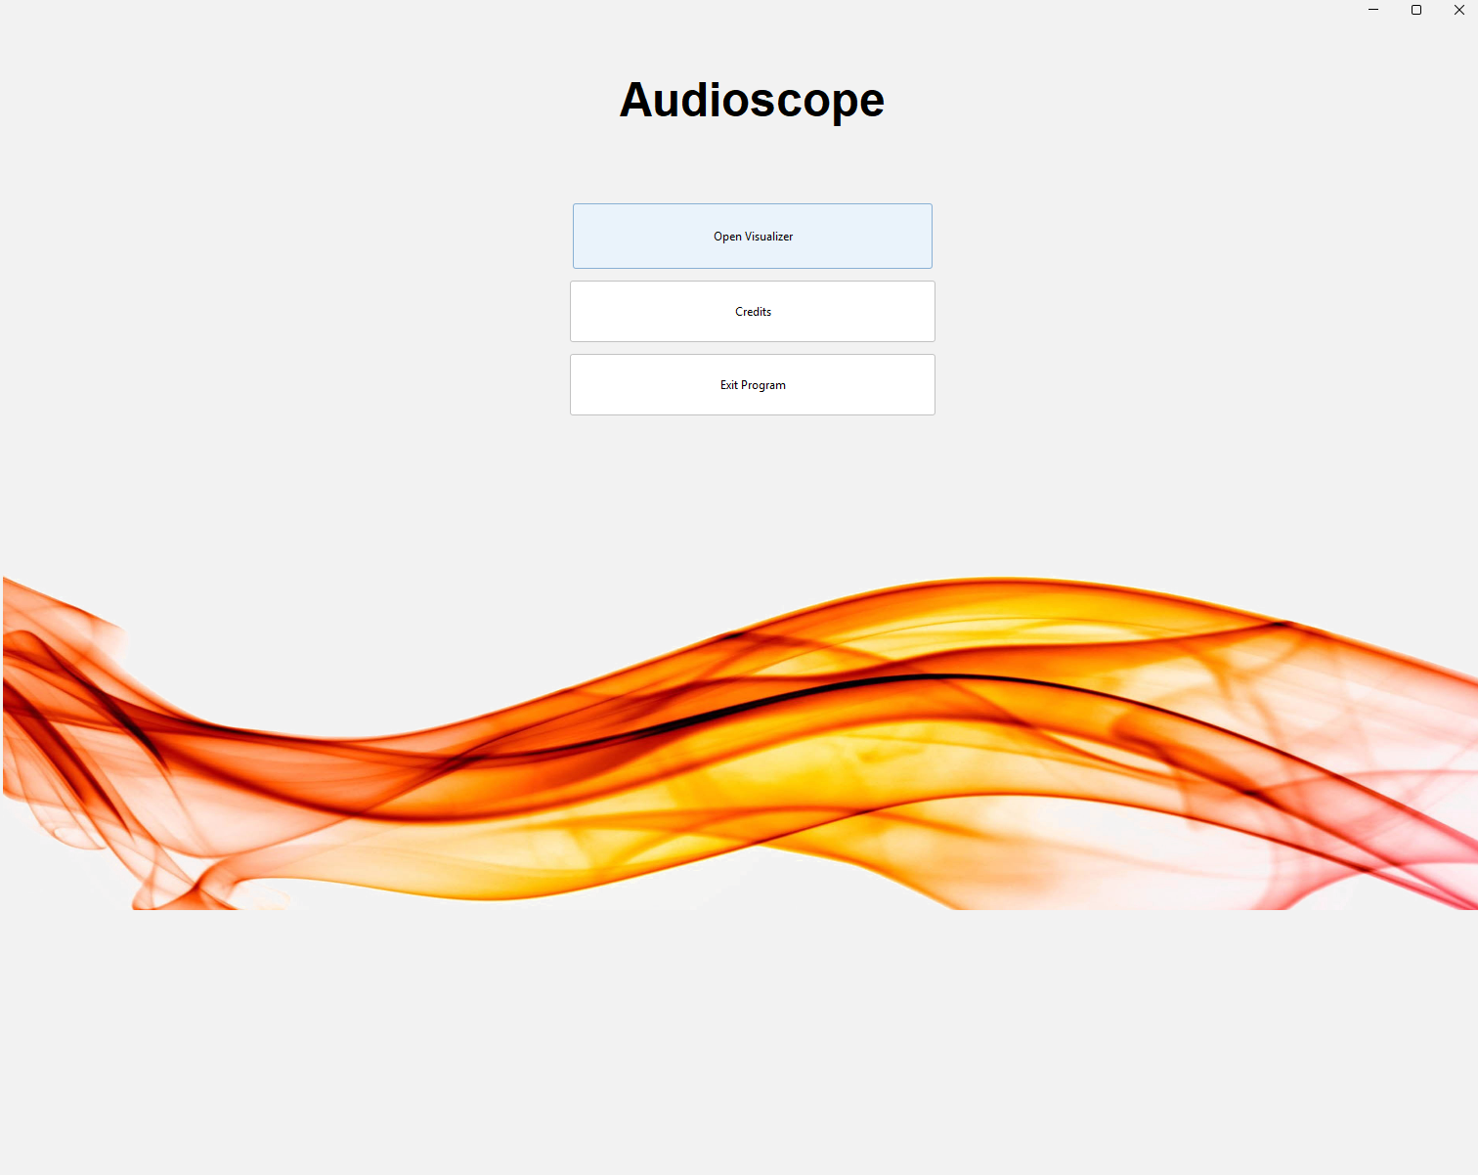

1. **How to Use**

## Start-up

Start the program by clicking on this manual's “Audioscope.jar” file. The start screen will be displayed upon startup. (For more details, refer back to Part **“B. Installing and running the program.”**)

## Start Screen

Upon opening the jar file, you will see this start screen. The menu is navigated through the use of your mouse cursor. Click your mouse on a button that you would like to select.



1. **Open Visualizer**

This option starts the application.

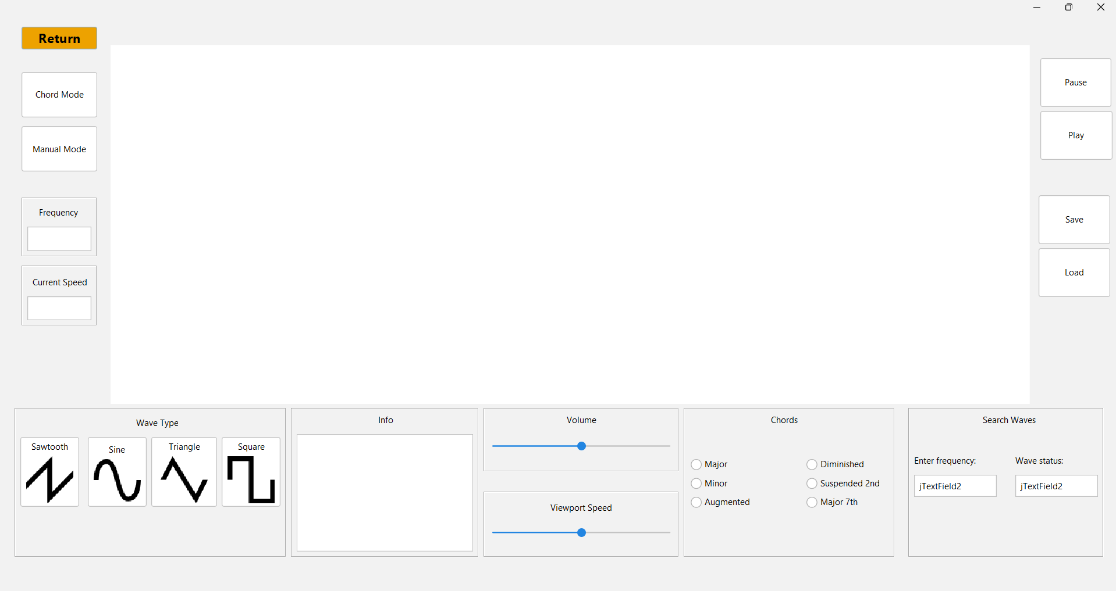

1. **Exit Program**

This option closes the project. Select the button that is labelled “Exit program”.



1. **Credits**

This option opens the credit screen. Return to the opening screen by pressing the button marked “return”.

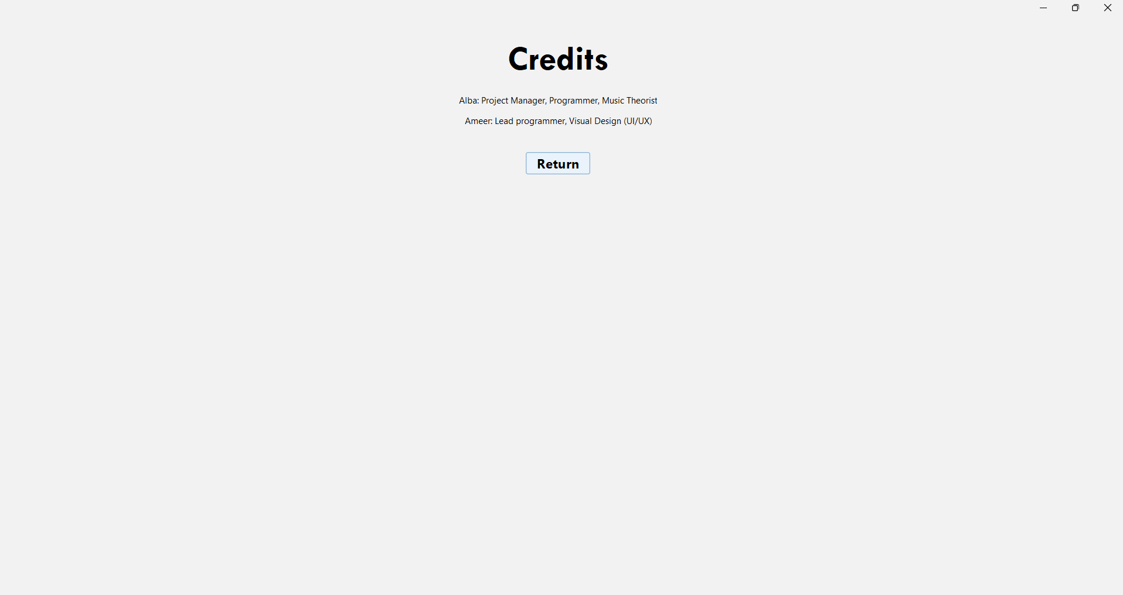

## Visualize

When you start the application, you will see the wave visualizer. To start displaying a wave, pick one of the following wave types shown in the bottom left corner. Press the return button on the top left corner to return to the start screen. 



1. **Pausing and playing the animation**

Press the pause button to pause the visual simulation, and press play to resume it. Note: this does not pause or play audio.



1. **Volume and viewport speed**

Drag your cursor on the speed bar to increase or decrease the simulation viewport speed. Viewport speed modifies the percent speed the wave is animated, allowing waves of higher frequencies to effectively be animated. Toggle the volume bar to change the volume.



1. **Chords**

Press any of the chord buttons to toggle harmonic waves that generate the chord, using the inputted base frequency as the guide. Be sure to select a wave type to see the visual chord animation. This panel is available as long as the panel is set to chord mode.



1. **Frequency and current speed**

In the text editor under “frequency,” the user can enter an integer, which toggles the frequency of the displayed wave. The current speed box displays the changes created by the viewport speed bar. It shows a percentage that represents how fast the wave is being shown to the full speed we can animate. For example, text showing 50% would mean that the wave is moving half as fast as it can be animated in the program.



1. **Chord mode and manual mode**

In the text editor under “frequency,” the user can enter an integer, which toggles the frequency of the displayed wave. The current speed box displays the changes created by the viewport speed bar. It shows a percentage that represents how fast the wave is being shown to the full speed we can animate. For example, text showing 50% would mean that the wave is moving half as fast as it can be animated in the program.



1. **Saving and loading**

A current wave or chord can be saved using the save button. A user can load a previously saved wave by selecting the load button. Note: the save button saves the waveform, frequency, and chord type, but no other presets, such as volume or viewport speed.



1. **Key features**
2. **Base frequency modification**: A user is able to toggle between frequencies 1-900 (inclusive) to create a variety of frequencies. A frequency is determined by an occurrence per second, and the program accurately depicts this.
3. **Chord modification:** A chord is a collection of frequencies. The different chord buttons allow a user to create many different chord combinations based on the base frequency.
4. **Waveform modification:** The shape of the waveform modifies the tonal quality of the output sound, as the sine wave has a softer sound, while a square wave is harsher.
5. **Volume modification:** The volume modifies the amplitude of the wave output through the speakers.
6. **Saving and Loading:** Saves the wave type and base wave frequency. Press load to load the most recent save.